A zine is a self-published collection of text and visuals usually made by physically cutting and pasting elements together before photocopying the master for distribution. Zines typically focus on content not found in mainstream media, use vibrant colors, and print only 50-100 copies (though the distributed photocopies are often printed grayscale). Zines remain a popular genre amongst subcultures due to the ease with which a zine is produced and distributed. | 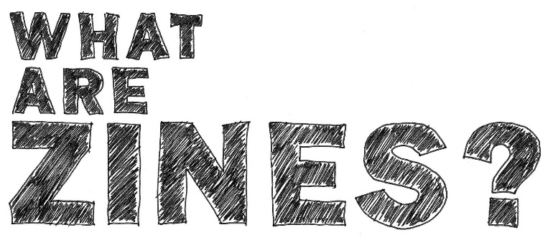  As a university-level writing project, a zine provides opportunities to work on multimodal composition, increase audience awareness, and mimic the journal design process.

ACTIVITY INSTRUCTIONS
Using the materials provided, create a zine page responding to the “High-Impact Practice” construct assigned to your table. You may include everything from general definitions to personal experiences. Here are some questions that might help generate ideas:

What does this construct look like in a writing assignment?
How might students respond to the expectations associated with this construct?
What is the benefit of incorporating this construct in a writing assignment?
What experiences do you have with assignments that include this construct?

