Pflugfelder

Top Ten-Hundred Words

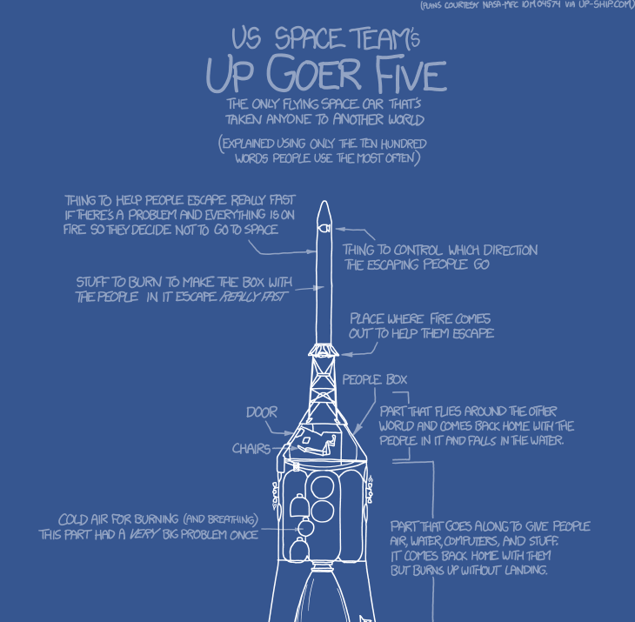
Originally, Randall Monroe, of XKCD comics fame (http://xkcd.com/), created a large diagram/technical descriptions of the Saturn 5 rocket. He attempted to describe all of the features and specifications of the rocket using only the top ten-hundred words in the English language. Why “ten-hundred”? Well, the word “thousand” isn't one of the top thousand words. Here’s a preview:

http://xkcd.com/1133/

The comic spread virally (as do so many of XKCD’s comics do) and soon there emerged a text editor, which highlights the words that are not in the top thousand words (MS Word-grammar-checker-style): http://splasho.com/upgoer5/. Avoiding all but the most common words asks you to pay a lot more attention to clarity and not only filters out jargon, but also any words that might need defining.

There are tips on the text editor, too, including:
- Technical' words can be 'enclosed' in single quotes if, for example, you need to 'define' them. 'Phrases_need_underscores'.
- You can refer to people by calling them Mr Surname or Mrs Surname (e.g. Mr Obama). If you want you can cheat slightly using this, for example referring to Mr Hydrogen and Mrs Oxygen.
- If you're stuck for something to write about try: your favorite food, the plot of a good book, or your area of expertise.

Naturally, this kind of writing practice is basically a kind of overcorrection and leads to some completely bizarre and un-readable passages, though it does help students understand that they need to be careful when using terms and concepts that require additional knowledge. I like it because it requires us to consider whether or not our audience really does know the definition of the terms we’re using and whether or not we need to include additional explanatory language or not.

Finally, there is a Tumblr blog dedicated to showcasing the best and worst of these compositions
http://tenhundredwordsofscience.tumblr.com/:

A bioreactor:
The thing we make is a round box with living stuff in it, and a turning thing to move the stuff around. The living stuff is made of really little animals, like tiny trees that live in water. We put in the stuff that the living stuff eats a little at a time, so that how much of that stuff is in the round box stays the same, and we take out the stuff the living stuff likes to make at the same. We make the whole thing warm and put air in it to keep the living stuff happy. Sometimes the living stuff needs light, so we make the round box out of glass.

We do all this stuff because the living stuff in the round box likes to eat a bad kind of air. This is the kind of air that makes the world get hotter. When it eats this air, it turns the air into sweet food. We can turn that sweet food into a thing we can burn in our cars and use to make lights in houses.

Software engineering:
“My job is to tell the computer to do things using words a computer understands. People want the computer to do some things for them so some part of their lives are easier, faster, or just better. My job is turning people’s wishes into words a computer can understand and do very well. Most times, there are many different ways to tell the computer what to do, and some ways are better than others. Computers will do exactly what you tell it to do, which is a good thing if you are thinking like your computer and a bad thing if you are not. Thinking about how you will tell the computer to do something can be both hard and fun. Sometimes, the words you tell the computer are not quite right, and you have to figure out why. It’s also interesting to work with other computer word people and figure out how to make our words work well together.”

High school math:
I help students find numbers. Sometimes, the numbers are pretending to be letters. Then, the students must use the numbers around the letters to find the hidden numbers.

Also, there are boxes and round things. The boxes and round things also have hidden numbers. But the boxes and round things are all the same as other boxes and round things, and you use the things that are the same to find the hidden numbers. I help students see that hidden numbers are easy to find.

Philosophy:
How should I live? What should I do in life? These are questions we all have to answer. Because we all have to live some way or the other. Big and small questions about the right way of doing things come up all the time. And our life as a whole is always our own attempt to answer the question about a good way of living.

Still many people don’t think much about these questions. They just live like they are supposed to live. They live like they believe other people would want them to live. And believe in things that people around them believe in. So they let other people decide about their lives.

But there are some people who feel that they must try to answer these questions. Who stop and ask: Should I really believe this? Should I really live like this? And they will not go on, before they know the answer. They are willing to go deeper and deeper and spend a lot of time with these questions. In fact, they can spend their whole life trying to figure out something other people think is not interesting at all.

In the best case, these people can find new answers to life’s big questions. Answers that open people’s eyes and change the way they look at their lives. This could change the way people are living. In the best case, these answers can help all of us to live our lives better.
This is what I do for work. I try to find new ways of thinking that will make people live a better life.

Volcanology:
There are bits of the ground with lots of fire. As well as fire, air comes out of these bits. This air is different to normal air. You wouldn’t want to breathe this air.

I look at how this different air changes the normal air. Sometimes I look at changes near the fire, sometimes I look at changes far away from the fire. Rain, cold, hot and wind are all important to this.

It is hard to took at air far away from the fire. I use a computer to guess how the air changes. The computer can be good but also can be bad. I try and make it good.

Accounting:
People who have money give it to people who have ideas. Then the ideas people go away and do stuff with the money. Each year, the money people ask if the ideas people have made money from the ideas. So, the ideas people tell a story of where the money came from and the things that the money bought . Now, sometimes the money people want their money back. But, instead of asking the ideas people to given the money back, the money people ask other money people to take their place. So the new money people buy from the first money people.

Now, I want to know if the new money people have paid too much. So I look at the stories that the ideas people have told. I look at the stories to see if there can be any new things that surprise the new money people after they have paid the first money people.

